Urban Design Asia 2009 (UDA 2009)
- Theme: Urban Sustainability on Asia
- November 20-21, 2009
- Korea University, Seoul, Republic of Korea
- Organized by UDIK and Korea University
- Speakers from 8 countries made 24 presentations
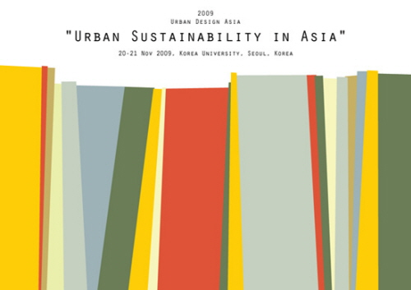
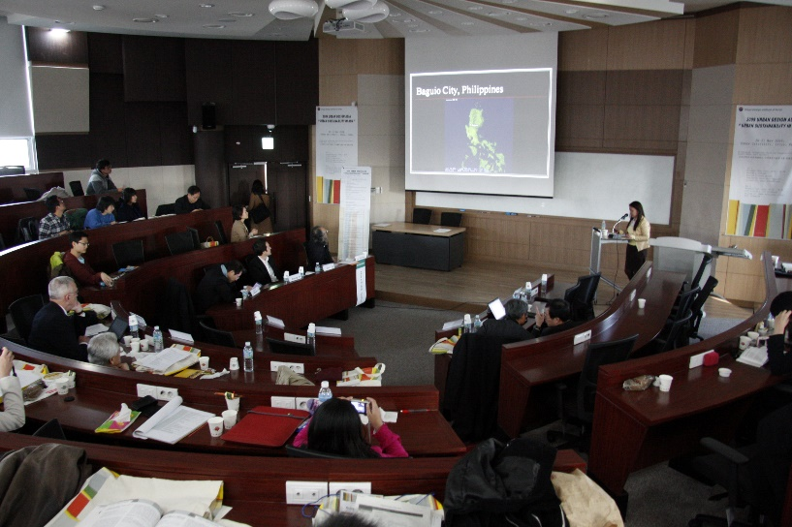
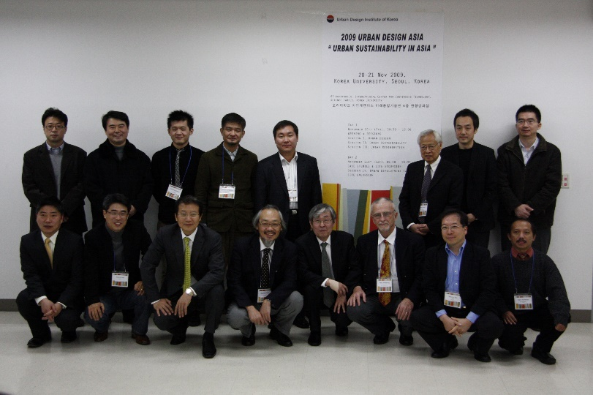
November 20 2009, Friday
09:30-10:00 | Registration
10:00-10:10 | Opening Remarks: Yeong-Te Ohn, President of UDIK
10:10-10:20 | Welcome Address: Dong-Sik Jang, Dean of College of Engineering, Korea University
10:20-10:50 | Keynote Speech: Ki Ho Kim, Vice President of UDIK
10:50-11:00 | Coffee Break
11:00-12:50 | Session 1: Urban Design
 | Moderator: Peter Armstrong
 | Designated Discussion: Chang Gyu Choi
 | Invited Paper
Mohammad Danisworo
Urban Transformation revolution: A Challence for Synergistic Process of Planning and Design to Shape Future Asian Cities - Case Study: Jakarta, Indonesia
Dongyun Kwak
Urban Designing as a Communication Process in Japan: Reconsideration of Community Design Program in Gyotoku, Ichigawa
Hye-jin Jung, Yun-suk Lee, Seiyong Kim
The Cases on the Actualization of Regional Public Amenity via 'District Unit Planning' in the City of Seoul
Heru W. Poerbo
Building Height Regulation in Indonesian Major Cities
Shuai-Ping Ku
The Landscape of Improvisation: Nexus of Culture and Narrative in Singang Township
Sang-wook Cho, Ji-won Moon, Hong-kyu Kim
An Analysis of the Users' Satisfaction on the Public Open Space of Downtown Redevelopment Districts in Seoul: Focused on Publicity
12:50-14:00 | Lunch
14:00-15:50 | Session 2: Urban Sustainability
 | Moderator: Haruhiko Goto
 | Designated Discussion: Joongseok Joseph Ryu
Xiangwang Meng, Tsuyoshi Setoguchi
Climate Responsive Urban Design Approaches for Lively Downtown areas in Winter Cities: Evaluation of Building Types through Wind Tunnel Simulation
Seunghyun Jung, Kyoosang Ryu
A Method for Analyzing Thermal Comfort in Ubiquitous-Ecological Cities
Donna G. Rillera-Tabangin
Measuring the Walkability of a Colonial Urban Historic Core and Its Implications to Climate Change
Choon-Hong Lee, Bong-ho Han, Kyong-Jae Lee
A Study on the Establishment of Sustainable Eco-Industry Park: With an Example of Banwol Industrial Complex
Ting Wang
Better Public Transport System Makes Better Urban Sustainability: Comparative Research Between China and France
Dongwoo Lee, Kyushik Oh, Jihye Park
Assessing Landscape Ecological Values of Greenbelt Areas in Seoul Metropolitan Area
15:50-16:10 | Coffee Break
16:10-18:00 | Session 3: Urban Regeneration
 | Moderator: Mahammad Danisworo
 | Designated Discussion: Choon Choi
 | Invited Paper
Haruhiko Goto
Lifescape as Social Capital
Grace C. Ramos, Gun-Hyuck Ahn
The Economic Undertones of New Towns and Gated Developments in Seoul and Manila
Yunjung Yun, Kwangjoong Kim, Byong-E Yang
A Study on Local Community Revitalization through Community Based Public Art Practices: Seoksu Art Project and Indeokwon Project
Nurul Dwi Purwanti, Hatma Cakrakusuma
Local Wisdom-based Alternatives to Government Policy in Urban Planning - An Indonesian Case Study
Soo-Young Koo, Young-Bum Kim, Yong-Hwan Park
An Architectural Study on the Re-organization of Spatial Composition of Urban Traditional Houses in Korea
Le Thi Hong Na, Jin-Ho Park
Adaptation Design of Vietnamese Traditional House to Meet the Requirements of Comfort Living in Modern High-rise Houses
Rezaee Naimeh, Rabiei Asmae, Torabi Mahdi
Re-Comprehending the Urban Structural Elements as a Means for the Reviving the Urban Historical Fabric - Case Study: Tehran-Iran
November 21 2009, Saturday
09:00-09:30 | Registration
09:30-11:50 | Session 4: Urban Development Cases
 | Moderator: Kyushik Oh
 | Designated Discussion: Seiyong Kim, Mohammad Danisworo
 | Invited Paper
Peter Armstrong
Urban Consolidation in KU-RING-GAI: The Impact of the NSW Government's Strategy for Higher Densities in Suburban Sydney
SAMWOO Architects & Engineers: Ki Yeon Kim
The Living Water: Magok Waterfront Development
Farid Esmaeil
XERITOWN: A Climate Responsive Urban Habitat
DA Group: Seung Ho, Yang
Woonbook Leisure Complex PF
HAEAHN Architecture: Jae Jun Ryu
Hangang Cinepolis
11:50-12:10 | Closing Remarks: Yeong-Te Ohn, President of UDIK  Announcement
12:30-18:30 | Site Excursion
18:30 | End of Program

Urban Design Asia 2012 (UDA 2012)
- Theme: Future Cities in Asia
- October 18, 2012
- Seoul Kyoyuk Munhwa Center, Seoul, Republic of Korea
- Organized by UDIK and AURI (Architecture & Urban Research Institute)
- 20 presentations
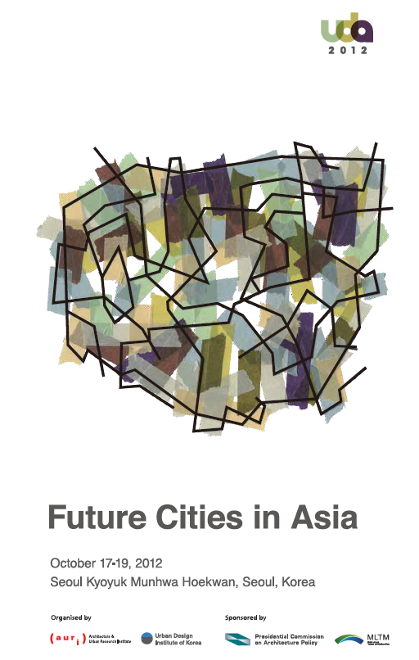

October 18 2012, Thursday
10:00-10:00 | Registration
10:00-10:30 | Opening Remarks: Haeseong Je, President of UDIK
10:30-11:00 | Welcome Address: Sang Jung Lee, Chief Commissioner of The Presidential Commission on Architecture Policy
11:00-12:00 | Keynote Speech 1  Future Asian Cities :  Urban Formations, Regional Reflections and Sustainable Developments  Peter G. Rowe, Harvard University  Keynote Speech 2  Historic Preservation in the Urban Planning Context of Seoul  Kiho Kim, University of Seoul
12:00-13:00 | Lunch
13:00-15:00 | Session 1: Invited Papers
 | Moderator: Seiyong Kim, Korea University
 | Designated Discussion: | Sohyun Park, Seoul National University  Hyunjoon Yoo, Hongik University
Johannes Widodo, National University of Singapore
A Contextual, Responsible, and Humane Urban Design and Planning in Asia
DU Liqun, Beijing Municipal Institute of City Planning and Design
Ideal Space for Beijing’s Central Axis Development
Aya Kubota, The University of Tokyo
Creating Diverse Tokyo as an Ensemble of Special Districts and Receptive Tokyo through Utilization of Heritage
Monica Kuo, Chinese Culture University
Urban Design Project in Taipei
15:00-15:30 | Coffee Break
15:30-18:00 | Session 2: Urban Design
 | Moderator: Daniel S. Oh, Konkuk University
 | Designated Discussion: | Monica Kuo  Chuyoung Tchah, Auri
Sirirat Sereerat
The‘ Self-made’ Public Place: A Spatio-Cultural Identity of Two Asian Cities
Suyeon Kim, Seoul National University
A Study on the Post Occupancy Evaluation of ‘ Community Street’in the Residential Complex : Focused on Eunpyung New-Town, Seoul, Korea
Seonhye Bae, Seoul National University
How to Review the Public Projects for Street Improvement: Proposing a Comprehensive Evaluation System
Sang-hoon Jeong, Harvard University
Foreign Property Developers’ Investment Patterns in Vietnam: The Apartment Market in Ho Chi Minh City
 | Session 3: Urban Sustainability
 | Moderator: Sunghoon Oh, Auri
 | Designated Discussion: | DU Liqun,  Johannes Widodo,
Wen-Liang Chen, Chung Yuan Christian University
Urban Transformation by Traffic Network and Politic Issue
Jun-hwan Song, The University of Tokyo
Evaluation and Typology of Area Management by Local Associations for Vitalizing Railway Station Areas in Japan
Wei Lun KUO, Chinese Culture University
International Workshop of Environmental Design Education through a Practical Program of Education
Jongjin Park, Swiss Federal Institute of Technology in Lausanne
Dynamics of Urban Centre and Notion of Weighted Mean
Seunghyun Kim, Seoul National University
Sustainable Landscape Design as Green Infrastructure
 | Session 4: Urban regeneration
 | Moderator: Youngsuk Kim, Konkuk University
 | Designated Discussion: | Aya Kubota  Jayoung Kim, Korea University
Guyoung Han, Seoul National University
Urban Design, Urban Economics, and Mega Shopping District
Haejin Yeo, Auri
Rethinking the Spatial & Cognitive Patterns of Neighborhood in Seoul
Irwan Soetikno, RTKL International
Mnemonic Practice: Hybrid Urban Village as Reconstruction of Memory of Places
R. Winton Danardi, Sepuluh Nopember Institute of Technology
Place Attachment in Kampung Kebon Dalem
Youngkyung Kim, Chung-Ang University
A Study on Network Belt of Method of Regeneration for Modern Industrial Heritage
18:00-18:20 | Closing Remarks: Haeseong Je, President of UDIK  Announcement

