Preparation of Papers for KSII Transactions on Internet and Information Systems

First_name A. Family_name¹, Adam B. Smith¹, and Minho Jo^{2*}
1 San Diego Supercomputer Center, University of California
San Diego, CA 92093 USA
[e-mail: yzeng@sdsc.edu]
2 Department of Computer Science and Software Engineering, Korea University
Sejong, South Korea
[e-mail: minhojo@korea.ac.kr]
*Corresponding author: Minho Jo

Received June 25, 2023; revised August 11, 2024; accepted October 12, 2024;
published January 31, 2025

Abstract

These instructions give you guidelines for preparing manuscript for KSII TIIS journal. Use this document as a template if you are using Microsoft Word 6.0 or later. Manuscript title should be written in 22-point Tahoma font and purple color. The first letter of each word in the manuscript title must be capitalized. In the author list, the first and last name should be written in full and the middle name should be abbreviated. Author name must be 10-point size in Times New Roman font. The author's affiliation must include an email address and be written 9 points after the author's name. You must indicate the corresponding author with * mark. The abstract title is 12-point Arial font and bold italic style in the center line while abstract itself should be written in the 11-point Times New Roman font. The abstract must be a concise yet comprehensive reflection of what is in your article. In particular, the abstract must be self-contained, without abbreviations, footnotes, or references. It should be a microcosm of the full article. The abstract must be between 150-250 words. Be sure that you adhere to these limits; otherwise, you will need to edit your abstract accordingly. The abstract must be written as one paragraph and should not contain displayed mathematical equations or tabular material. The abstract should include 5-6 different keywords or phrases, as this will help readers to find it. The keyword title is 12-point in Arial font type and bold italic style. However, keywords should be written in the 11-point Times New Roman font. It is important to avoid over-repetition of such phrases as this can result in a page being rejected by search engines. Ensure that your abstract reads well and is grammatically correct.

Keywords: Enter key words or phrases in alphabetical order, separated by commas.
1. Submitting Original Papers and Plagiarism Policy
All authors are required to submit original manuscripts that have not been submitted or published in other journals. If the same paper appears or has been published in any other publication, it will be automatically rejected. Papers presented at other academic events such as conferences, workshops, seminars or symposiums can be reviewed and published by KSII TIIS. However, in this case, the submitted manuscript must contain at least 30% of new content that has never been published in other publications. This means that the submitted manuscript does not need to provide new results compared to the previously presented manuscript, but more detailed and elaborate explanations and extensions must be made in core ideas, cases, explanations, figures, tables, etc.
In the footnote at the bottom left of the first page, you must indicate the name and date of the conference where the paper was published. The authors outline very briefly how new submissions provide significant novel contributions over previously published papers. We strictly prohibit plagiarism including self-plagiarism. Authors involved in plagiarism cases are subject to severe penalties.
2. Guidelines for Manuscript Preparation
Your manuscript must be at least 13 pages, including figures, tables, and figures, but no more than 21 pages. The page size of the manuscript is 20.5cm (width) x 27.3cm (height), with one column page and single-line spacing. The section title should be written in Arial font type, 12-point size, purple and bold. The text should be written in the 11-point Times New Roman font.
All paragraphs except the first one must be indented. All references are numbered in the order they appear in the text. Reference numbers in the text are red [1].
2.1 Types of Graphics
The sub-section title should be written in 11-point size using Arial font style, block color, and bold strokes.
2.1.1 Color
Authors are strongly encouraged to use colors in figures, tables, and photos to enhance legibility and clearness
2.1.2 Figure
The figure and figure title should be centered on the page. The title of the figure is at the bottom of the picture. The title uses the 10-point Times New Roman font. All figures are numbered in the order they appear in the text. As you can see in Fig. 1~Fig.4, the figure should be bold blue in both the body and the title.
2.1.3 Table
The table and its title should be centered on the page. The title is placed at the top of the table. The title uses the 10-point Times New Roman font. All tables are numbered in the order they appear in the body. As shown in Table 1, both the table and its title must appear in bold blue.

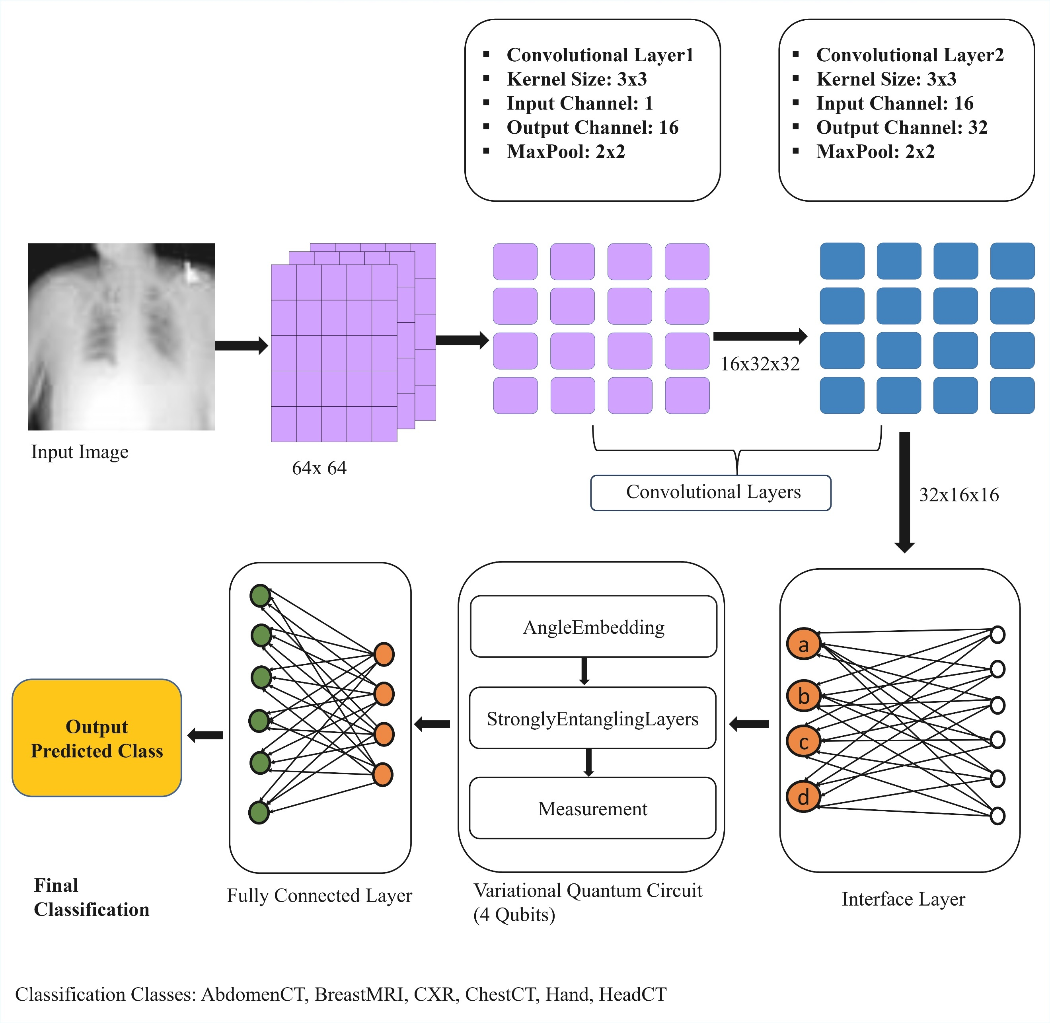
Fig. 1. Note that figure is abbreviated as “Fig. 1”. There is a period after the figure number, followed by two spaces. The figure and figure title should be centered on the page.
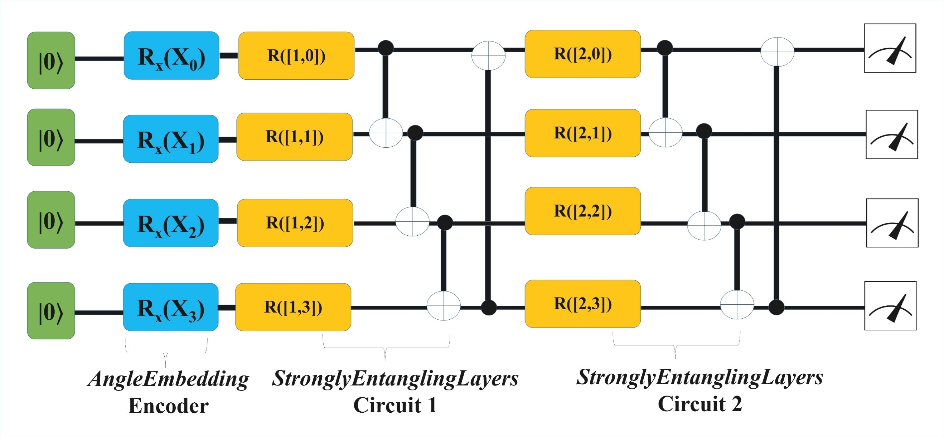
Fig. 2. Note that figure is abbreviated as “Fig. 2”. There is a period after the figure number, followed by two spaces. The figure and figure title should be centered on the page.
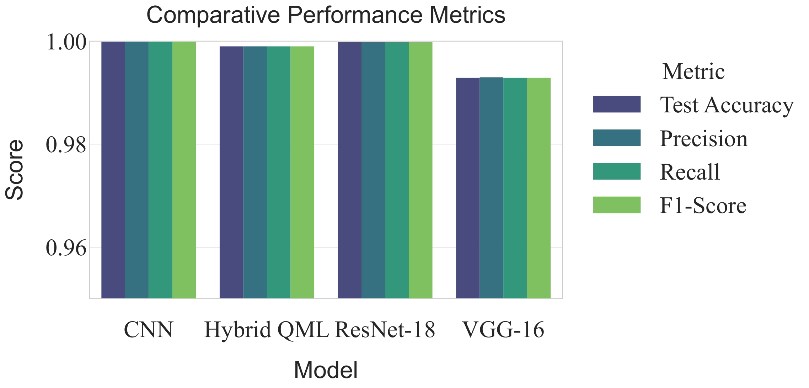
Fig. 3. Note that figure is abbreviated as “Fig. 3”. There is a period after the figure number, followed by two spaces. The figure and figure title should be centered on the page.

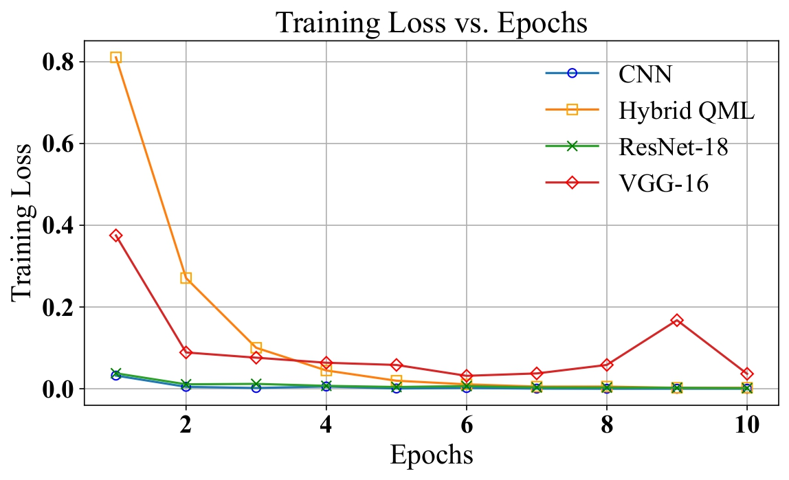

Fig. 4. Note that figure is abbreviated as “Fig. 4”. There is a period after the figure number, followed by two spaces. The figure and figure title should be centered on the page.

Table 1. Applications in each class

Class | Applications | Total number
Transactional | 53/TCP, 13/TCP, 111/TCP,… | 112
Interactive | 23/TCP, 21/TCP, 43/TCP, 513/TCP, 514/TCP, 540/TCP, 251/TCP, 1017/TCP, 1019/TCP, 1020/TCP, 1022/TCP,… | 77
Bulk data | 80/TCP, 20/TCP, 25/TCP, 70/TCP, 79/TCP, 81/TCP, 82/TCP, 83/TCP, 84/TCP, 119/TCP, 210/TCP, 8080/TCP | 1,351

2.1.4 Author bio and Photo
The author profile should be presented at the end of the submitted manuscript. When the paper is accepted, a photo of the author with the face and shoulders in JPG or GIF format is requested later.
3. Math
If you are using Word, use either the Microsoft Equation Editor or the MathType add-on (http://www.mathtype.com) for equations in your manuscript. “Float over text” should not be selected.
3.1 Equations
As shown in (1), numbers should be vertically centered with regards to the equation and aligned to the right of the page. Additionally, equation numbers in parentheses should be numbered consecutively. To create an equation use the equation function in Word.
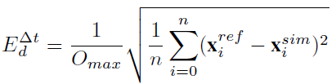

(1)

Make sure the symbol of the equation is defined before or immediately after it appears. When you need to refer to an equation, use "(1)" rather than "Eq. (1)" or "equation (1)". However, at the beginning of a sentence, use "Equation (1) is ....".
4. Units
The SI base unit is highly recommended. More information can be found at http://itiis.org/author-guide.
5. Reference Examples
The reference uses 10-point Times New Roman font. It should be indented from the second
line. All references in the manuscript must have DOI links. If the reference does not have its
own DOI, you do not need to add the DOI. Almost every journal article has a DOI, so you can
find the DOI on Google using the journal article title. When adding DOIs to your reference,
you need to put the prefix http://doi.org/ before each DOI. Finally, place the cursor on the DOI
link, right-click and select the “Hyperlink Edit” menu. Enter the tag name "Article (CrossRef
Link)" in the text box. Also, since "Article (CrossRef Link)" is a link address, it must be passed
to the next line if the text is cut off (i.e., it spans two lines).
Below is a list of commonly used reference types. Please refer to these categories when
preparing your references:

• Journal Papers [1]
• Conference Papers [2,3]
• Papers (to be published) [4,5]
• Online Resources [6]
• Thesis and Dissertation [7]
• Unpublished Manuscripts [8]
• Periodicals [9]
• Books and Book Chapters [10–14]
• Technical Reports and Handbooks [15–18]
• Electronic Documents and Computer Programs [19]
• Patents [20, 21]
• Standards [22, 23]
• Articles with Article Numbers [24, 25]
6. Conclusion
In the conclusion, you can reiterate the main points of the paper, but do not duplicate the abstract as a conclusion. You can elaborate on the importance of the task or suggest applications and extensions.
Appendix
Appendices, if needed, appear before the acknowledgment.
■ Source Code Download: https://github.com/tiansoul/QCHFT-Quantum-Cross-Hybrid-Fine-Tuning-for-LLMs/tree/main
Acknowledgement
Use the singular heading even if you have many acknowledgments. In most cases, sponsor and financial support acknowledgments are placed in the unnumbered footnote on the first page, not here.
References
- Z. Hu, Y. He, Y. Shen, M. Jo, M. Collotta, G. Shen, and X. Kong, “Vehicular Social Dynamic Anomaly Detection With Recurrent Multi-Mask Aggregator Enabled VAE,” IEEE Trans. Intell. Transp. Syst., vol. 25, no. 12, pp. 21 709–21 722, Dec. 2024. Article (CrossRef Link)
- D. Jeong, J. Lee, I. G. P. S. Wijaya, and M. Jo, “Dynamic NFT Plants Synchronized with Real Plants through IoT Monitoring,” Presented at APIC-IST 2024, Takamatsu, Japan, 2024. [Online]. Available:
https://d2j16w31g89z0j.cloudfront.net/site/apicist2024/Proceedings_of_APIC-IST_2024.pdf
- S. Kim, H. Jeong, G. Fenza, and M. Jo, “Detecting Pedestrians at Night Using LiDAR and Camera Fusion Data for Autonomous Driving,” in Proc. APIC-IST 2024, Takamatsu, Japan, 2024, pp. 207–208. [Online]. Available:
https://d2j16w31g89z0j.cloudfront.net/site/apicist2024/Proceedings_of_APIC-IST_2024.pdf
- S. Kim, G. P. S. Wijaya, J. Baek, and M. Jo, “Bayesian Deep Learning Approach for Traffic Accident Severity Prediction with Uncertainty Estimation,” Presented at the 17th Int. Conf. ICONI 2025, Okinawa, Japan, 2025. [Online]. Available:
http://iot.korea.ac.kr/file/ProfMinhojo/Bayesian%20Deep%20Learning%20Approach%20for%20Traffic%20Accident%20Severity%20Prediction%20with%20Uncertainty%20Estimation.pdf
- B. Kim, K. Lim, and M. Jo, “Forecasting Annual Rice Production Using a State-Space Model with Ridge Regression,” Presented at the 17th Int. Conf. ICONI 2025, Okinawa, Japan, 2025. [Online]. Available: http://iot.korea.ac.kr/file/ProfMinhojo/Forecasting%20Annual%20Rice%20Production%20Using%20a%20State-Space%20Model%20with%20Ridge%20Regression.pdf
- LectureNotes AI, “LectureNotes AI: Ultimate AI Notetaking Tool,” 2025. [Online]. Available: https://lecturenotes.ai. Accessed on: Nov. 25, 2025
- N. Kawasaki, “Parametric study of thermal and chemical nonequilibrium nozzle flow,”
M.S. thesis, Dept. Electron. Eng., Osaka Univ., Osaka, Japan, 1993.
- A. Vaswani, N. Shazeer, N. Parmar, J. Uszkoreit, L. Jones, A. N. Gomez, L. Kaiser, and
I. Polosukhin, “Attention Is All You Need,” arXiv, 2017, arXiv:1706.03762. [Online]. Available: https://arxiv.org/abs/1706.03762
- M. Chung and J. Kim, “The Internet Information and Technology Research Directions
based on the Fourth Industrial Revolution,” KSII Trans. Internet Inf. Syst., vol. 10, no. 3,
pp. 1311–1320, Mar. 2016. Article (CrossRef Link)
- W. K. Chen, Linear Networks and Systems. Belmont, CA, USA: Wadsworth, 1993.
- G. O. Young, “Synthetic structure of industrial plastics,” in Plastics, J. Peters, Ed. New
York, NY, USA: McGraw-Hill, 1964, pp. 15–64.
- ZOmega Terahertz Corp., The Terahertz Wave eBook. ZOmega Terahertz Corp., 2014.
[Online]. Available: https://www.scribd.com/document/322662319/Thz-zomega-ebook
-pdf-1206-sr-pdf
- D. P. Bertsekas, “Convex Optimization Theory.” 1 Chestnut St, Ste 222, Nashua NH
03060, USA: Anthena Scientific, 2009, pp. 164–167. [Online]. Available: https://web.mi
t.edu/dimitrib/www/Convex_Theory_Entire_Book.pdf#page=175.72
- P. B. Kurland and R. Lerner, The Founders’ Constitution, Chicago, IL, USA, 1987. [Online]. Available: http://press-pubs.uchicago.edu/founders/
- E. E. Reber, R. L. Michell, and C. J. Carter, “Oxygen absorption in the earth’s atmosphere,” Aerospace Corp., Los Angeles, CA, USA, Tech. Rep. TR-0200 (4230-46)-3, Nov. 1988.
- R. E. Davis and J. R. Cogdell, “Calibration program for the 16-foot antenna,” Elect. Eng. Res. Lab., Univ. Texas, Austin, TX, USA, Tech. Rep. Tech. Memo. NGL-006-69-3, Nov. 1987.
- Motorola, Semiconductor Data Manual, Motorola Semiconductor Products Inc., Phoenix, AZ, USA, 1980.
- R. J. Hijmans and J. van Etten, “Raster: Geographic analysis and modeling with raster data,” 2012. [Online]. Available: http://CRAN.R-project.org/package=raster
- U.S. Congress, “The Declare War Clause, Part 3: Authorizations for Use of Military Force and Debate over Initiating Military Action,” Sep. 2024. [Online]. Available: https://www.congress.gov/crs-product/LSB11232
- G. Brandli and M. Dick, “Alternating current fed power supply,” U.S. Patent 4 084 217, Nov. 4, 1978. [Online]. Available: https://patents.google.com/patent/US4084217A/en
- Musical toothbrush with mirror. by L.M.R. Brooks. (1992, May 19). Patent D 326 189 [Online]. Available: https://patents.google.com/patent/USD326189S/en
- IEEE Criteria for Class IE Electric Systems for Nuclear Power Generating Stations, IEEE Standard 308, 1970. Article (CrossRef Link)
- Letter Symbols for Quantities, ANSI Standard Y10.5-1968.
- R. Fardel, M. Nagel, F. Nuesch, T. Lippert, and A. Wokaun, “Fabrication of organic lightemitting diode pixels by laser-assisted forward transfer,” Appl. Phys. Lett., vol. 91, no. 6, 2007, Art. no. 061103.
- J. Zhang and N. Tansu, “Optical gain and laser characteristics of InGaN quantum wells on ternary InGaN substrates,” IEEE Photonics J., vol. 5, no. 2, 2013, Art. no. 2600111. Article (CrossRef Link)
Author Profile


Minho Jo received the B.A. degree from the Department of Industrial Engineering, Chosun University, Gwangju, South Korea, in 1984, and the Ph.D. degree from the
Department of Industrial and Systems Engineering, Lehigh University, Bethlehem, PA, USA, in 1994. He is a Full Professor with the Department of Computer Science and Software Engineering, Korea University, Sejong, South Korea, where he is the Director of the
IoT & AI Lab. Prof. Jo is currently the Director of Brain Korea 21 [IoT Data Science Team] sponsored by the Korean government. Prof. Minho Jo is named in 2024, 2025 World’s TOP 2 Scientists List by Stanford University and Elsevier. His current research interests include IoT, generative LLM, quantum computing and quantum AI, blockchain/security, optimization theory, and autonomous vehicles. The average number of citations per publication authored by Prof. Minho Jo (from 2015 through 2024) is 57.2 and the Average Field-Weighted Citation Impact (FWCI) of Prof. Minho Jo (from 2015 through 2024) is 4.92 (based on SCOPUS SciVal.)
Prof. Jo is a recipient of the 2018 IET Best Paper Premium Award by the United Kingdom’s Royal Institute of Engineering and Technology. He was awarded with 2011 Headong Outstanding Scholar Prize. He is one of the founders of the Samsung Electronics LCD Division. He is the Founder and the Editor-in-Chief of KSII Transactions on Internet and Information Systems (SCIE/JCR and SCOPUS indexed. https://тииs.org/board). He was the South Korea’s Presidential Commission on Policy Planning (Chair of AI and Big Data TF Team). He served as an Associate Editor of IEEE INTERNET OF THINGS JOURNAL, IEEE SYSTEMS JOURNAL, IEEE ACCESS, Editor of IEEE WIRELESS COMMUNICATIONS, and Editor of NETWORK, respectively.

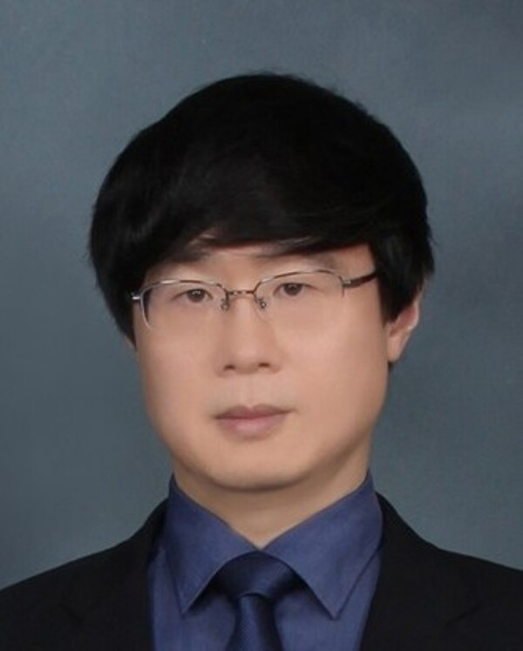
Jong-Moon Chung is an IEEE Fellow and professor in the School of Electrical and Electronic Engineering, Associate Dean of the College of Engineering, and Professor of the Department of Emergency Medicine in the College of Medicine at Yonsei University (Seoul, South Korea). He is an IEEE Fellow and member of the National Academy of Engineering of Korea (NAEK). He received B.S. and M.S. degrees in electronic engineering from Yonsei University and Ph.D. in electrical engineering from the Pennsylvania State University. From 1997 to 1999, he was an Assistant Professor and Instructor at the Pennsylvania State University in the Department of Electrical Engineering. From 2000 to 2005, he was with the Oklahoma State University (OSU) as a tenured Associate Professor in the School of Electrical & Computer Engineering. Currently he is a Vice President of the IEEE Product Safety Engineering Society (PSES), Director of the IEEE Consumer Technology Society (CTSoc), Senior Editor of the IEEE Transactions on Consumer Electronics, Section Editor of the Wiley ETRI Journal, and Chair Editor-in-Chief of the KSII Transactions on Internet and Information Systems.
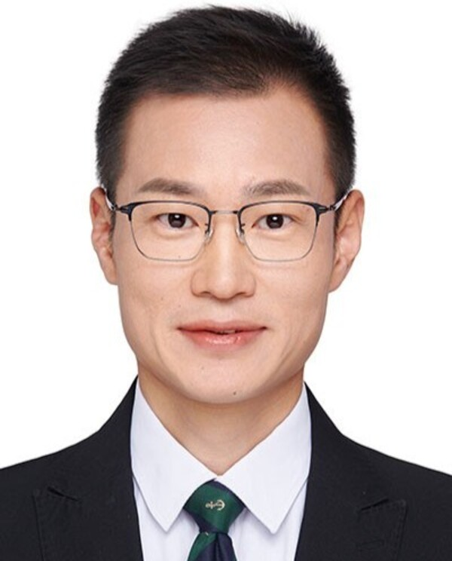
Guan Gui received his Ph.D. degree from the University of Electronic Science and Technology of China, Chengdu, China, in 2012. From 2009 to 2014, he was a research assistant and postdoctoral research fellow at Tohoku University, Japan. From 2014 to 2015, he was an Assistant Professor at Akita Prefectural University in Japan. Since 2015, he has been a Professor at Nanjing University of Posts and Telecommunications, China. His research focuses on intelligent sensing and recognition, intelligent signal processing, and physical layer security. Dr. Gui has authored over 200 IEEE journal and conference papers and received several best paper awards, including at ICC 2017, ICC 2014, and VTC 2014-Spring. He is a fellow of IEEE, IET, and AAIA, and he is recognized for his contributions to intelligent signal analysis and wireless resource optimization. Among his accolades, he received the IEEE Communications Society Heinrich Hertz Award in 2021 and was named a Clarivate Analytics Highly Cited Researcher from 2021 to 2024. Dr. Gui is a Distinguished Lecturer for the IEEE Vehicular Technology Society (VTS) and the IEEE Communications Society (ComSoc). He is an editorial board member for several leading journals, including the IEEE Transactions on Information Forensics and Security, IEEE Internet of Things Journal, and IEEE Transactions on Vehicular Technology. Additionally, he serves as the Editor-in-Chief of KSII Transactions on Internet and Information Systems. He has also held prominent roles in international conferences, such as Executive Chair of IEEE ICCT 2023, Executive Chair of VTC 2021-Fall, and Vice Chair of WCNC 2021.

